UCD Michael Smurfit Graduate Business School

MSc in Management

Business and Financial Environment

Prof: Jim Power

Individual Assignment: Global Economy

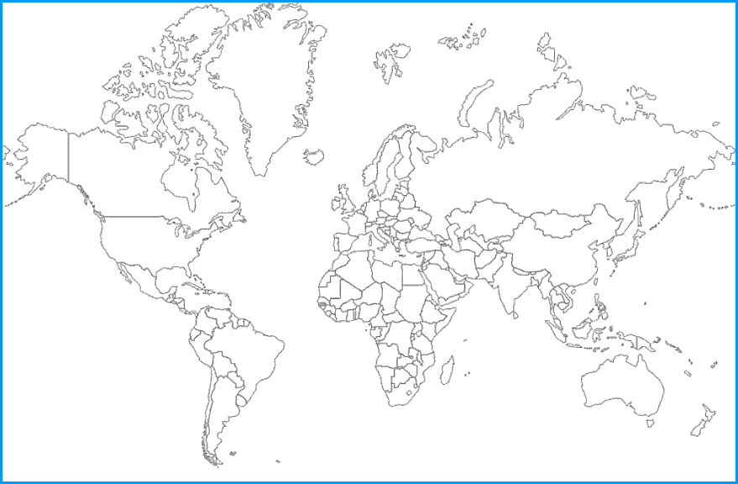

By Prachi Jain

(Student Number: 14202575)

Global Economy

**Global economy** refers to the **capitalization** and **inter-relations** between different economies of the world. Global economy is directly strengthened by the ‘**power of giving**’ resources, intellect, manpower and essentials for the welfare of human being; thus allowing people to live, work and prosper in the era of globalization. The world is changing at an unprecedented pace and so is global economy. 193 UN members and 2 sovereign states as [Kosovo](http://geography.about.com/library/maps/blkosovo.htm) and [Vatican City](http://geography.about.com/library/maps/blvatican.htm) build the global economy; hence any effect in any part of the world will have some impact on global economy. .[1] As per the July 2013 records more than **$10.5 trillion** exist in the world, out of which only **$1.2 trillion** can be easily liquidated. This total count consist of liquid currency,checkable accounts, money market funds, saving accounts, travelers' checks and CDs under $100,000. [2] All the economies of **195 countries** in the world can be broadly divided into three main domains as developed economies, economies in transition and developing economies. [6] The fact that **triggers** most of the challenges in the global economy is the fact that more than **80% of world’s population** live with **less than 10$ a day**. The huge differences among different economies put forth the extreme challenges such as **migration**, where immigrants migrate to different countries in search of new opportunities; under-developed economies face more **economic pressure** and debt. The brief overview of extreme challenges and broader view to un-riddle those challenges are listed below:

1. **Lack of quality education and skilled labor force**

In **developed countries** of the world, the **graduates** from the colleges **lack skills** required in the industries and hence corporate companies bear major expense as a part of on-job-training. Hence such inefficiency creates stress for students as well as companies that contribute to the economy by paying taxes and reducing unemployment. The only way to **solve** this difference is by allowing **industrial experts** to **collaborate** with the **university scholars** to design the curriculum for the students. They must **encourage** disciplines that have **huge demand** or has a **potential** to create demand in the market. Since ages students are studying same syllabus with very insignificant updates; thus in **developing** countries 2/3rd of the **graduates** **do not** contribute to the country’s **economy**. Knowledge that cannot be applied to contribute to the society and/or generate wealth is a waste knowledge. Hence it is very important to contribute to the economy by **developing** the **skilled labor force**.

|  |  |  |  |  |  |  |  |  |  |  |  |  |  |  |  |  |  |  |  |  |  |  |
| --- | --- | --- | --- | --- | --- | --- | --- | --- | --- | --- | --- | --- | --- | --- | --- | --- | --- | --- | --- | --- | --- | --- |
| chart) | 70000.0 |  |  |  |  |  |  |  |  |  |  |  |  |  |  |  |  |  |  | 450 |  |  |
| constant 1990 US dollars (bar | 60000.0 |  |  |  |  |  |  |  |  |  |  |  |  |  |  |  |  |  |  | 400 | employed (1990=100) (line) |  |
|  |  |  |  |  |  |  |  |  |  |  |  |  |  |  |  |  |  |  |  |
|  |  |  |  |  |  |  |  |  |  |  |  |  |  |  |  |  |  |  | 350 |  |
| 50000.0 |  |  |  |  |  |  |  |  |  |  |  |  |  |  |  |  |  |  | 300 |  |
|  |  |  |  |  |  |  |  |  |  |  |  |  |  |  |  |  |  |  |  |
| 40000.0 |  |  |  |  |  |  |  |  |  |  |  |  |  |  |  |  |  |  | 250 |  |
|  |  |  |  |  |  |  |  |  |  |  |  |  |  |  |  |  |  |  |  |
| 30000.0 |  |  |  |  |  |  |  |  |  |  |  |  |  |  |  |  |  |  | 200 |  |
|  |  |  |  |  |  |  |  |  |  |  |  |  |  |  |  |  |  |  |  |
|  |  |  |  |  |  |  |  |  |  |  |  |  |  |  |  |  |  |  |  |  |
| GDP per employed in | 20000.0 |  |  |  |  |  |  |  |  |  |  |  |  |  |  |  |  |  |  | 150 | Growth in GDP per |  |
|  |  |  |  |  |  |  |  |  |  |  |  |  |  |  |  |  |  |  |  |
|  |  |  |  |  |  |  |  |  |  |  |  |  |  |  |  |  |  |  | 100 |  |
| 10000.0 |  |  |  |  |  |  |  |  |  |  |  |  |  |  |  |  |  |  | 50 |  |
|  |  |  |  |  |  |  |  |  |  |  |  |  |  |  |  |  |  |  |  |
| 0.0 |  |  |  |  |  |  |  |  |  |  |  |  |  |  |  |  |  |  | 0 |  |
| India | China | Indonesia | South Africa | Brazil | Russian Federation | Mexico | Turkey | Argentina | Saudi Arabia | Korea, Republic of | Germany | Japan | Italy | Canada | Australia | United Kingdom | France | United States |  |  |

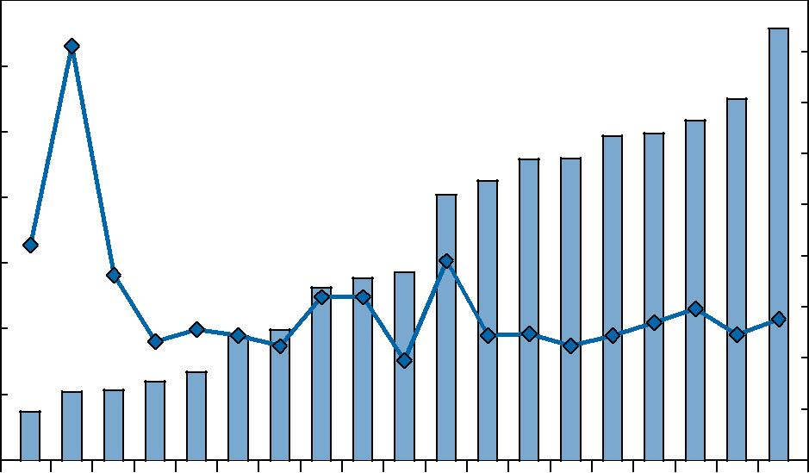

**GDP per person employed, 2008 (constant 1990 US$ at PPP), and change since 1990** [17]

The UN statistics states more than 100% growth in primary education enrollment in the world which is a very good indicator for enhancement of education. In most populated countries of the world the GDP growth per person employed is also very large.

1. **Unequal distribution of Money**

**25.4 %** of the world’s wealth is with **USA** which is followed by Japan, China, UK, and Germany thus accounting 9.86%, 8.77%, 4.71% and 4.65% respectively. Thus this deprives the least progressed countries to hold significant amount of wealth in the world. [7] **82.7%** of the world’s **income** is earned by roughly **20% of world population**. [11]

This unequal distribution of wealth can be **resolved** when the **rich people invest** in new ventures, thus **creating jobs** for majority **middle class people**. The other solution to overcome this issue is **charity** for a **social cause** like educating the unprivileged children, empowering women, supplying food and welfare etc.

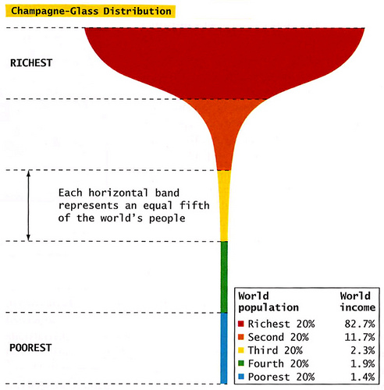

**Distribution of wealth in the world** [8]

1. **Lack of sincerity in policies of countries**

In majority developing and under developed nations of the world **violating policies** is the major problem that needs to be addressed. The key policy areas that will sharply affect the world economy in 2014 and future are **Chinese reforms**, **Japanese experiments** and **U.S. tapering**. [5] Chinese re-forms developed a serious imbalance in their economy which could lead to slow down which can pull the market demands in two ways and further lead to bankruptcies of major businesses. On the other hand Japan’s new Prime- minister Shinzo Abe made dramatic changes in macro-economic policies; thus affecting the global economy. USA suffers debt due to long term loan from World Bank for its military operations against Afghanistan, which has a very negative impact on the global economy. This can be **solved** by **sincere implementation** and **interference** of world organization.

1. **Lack of entrepreneurial ventures**

Entrepreneurs either engage in **fixing a problem** or **selling a new product** thus fulfilling the market demand. Entrepreneurial ventures not only help in improvising the **discrepancies** in the existing market but also help people showcase their talent, idea and expertise. Encouragement of entrepreneurship **directly contributes** to the world economy as it successfully creates employment and generates more opportunities for innovations. Technology entrepreneurship leads to automation of the system and development of new skill-sets. This automation empowers major corporations to increase the quality, reduce the labor cost, production cost and cost of the goods. (Thus efficient systems do encourage the entrepreneurs to establish a concrete solution to majority problems) Setting up incubators, expert advising and guiding students and adults will help foster the economy to a great extent. Incubators will create a platform for market exposure, an opportunity to exchange ideas and meet people from diverse backgrounds.

**Startup at early stage (OECD Records)** [22]

1. **Lack of quality supplies to meet the demand**

The problem is **inefficient manufacturing techniques** that lead to production of **mediocre quality products** and generates high quantity waste material. Hence it is very important to know and analyze the production techniques. Quality demand can be **achieved** only in a **non-monopolistic market** where competition leads to improvisation of the product/services at relatively low-cost. (Major examples are food, airline service and IT service sectors) Next 40% of the world’s population demands for more 50% of world’s agricultural resources. The statistics indicate that **200000 people add to the food demand every-day**. [21] Hence, the future of global economy majorly relies on global food and water supplies.

1. **War**

**War** between nations causes calamities like **drought**; **loss of life**, **loss of fertility**, **vegetation**, and livestock; pollution of water bodies and at times **total economic collapse**. It directly affects **macro-economy** by raising the deficits of the total GDP. For example, a decade war between **USA** and **Iran & Afghanistan** affected the GDP by **1%**. Currently the war between Ukraine and Russia and Federal State of Novorossiya had major conflict on over-taking the territories of [Donetsk](http://en.wikipedia.org/wiki/Donetsk_Oblast) and [Luhansk](http://en.wikipedia.org/wiki/Luhansk_Oblast) oblasts under Ukraine. Wars lead to billions to trillions of dollars of massive destruction and essential resources are also depleted. They largely impact the global economy and welfare of citizens of the fighting countries. Conflicts in Russia, Ukraine, Israel, Iran, Turkey and Kazakhstan are the major concern for the global economy. [9] **One-forth part of Iraq**, known to be the fifth largest oil reserves in the world, is captured by ISIS thus affecting the ownership of **25% of the oil reserves** that adds to major part of the Iraq’s economy and World resources. Only **mutual understanding**, **mediators** and **policy makers** can bring such conflicts to a halt.

1. **Political events directly impacting world economies**

Different political events in major economies lead to **different policies** being implemented which creates overall **ambiguity**. These policies also affect the world businesses and may either incur losses or gains. **Encouragement of FDIs** in any country directly affects the world trade and hence world economy. Hence the world economy has **direct links** with the political events that affects major economies of the world. It is understood that global economy is directly affected by political events in the major economies of the world. [16]

1. **Cultural barriers affecting/ limiting globalization**

The growth of global economy highly demands **globalization**. Cultural barriers can be solved by encouraging citizens of different countries come together and work on different issues. Cultural barriers affect the economy as a whole by discouraging the cultural mix. The progress of a nation directly depends on its relation with other countries of the world. [14] When 7.2 billion people interact with each other overcoming cultural barriers and welcoming diversity, exchange of knowledge and skills will lead to creation of new opportunities in the world of business. **Student exchange programs**, **international corporate meetings**, diversity amongst employees in a particular company, **international cultural programs** and **international sports events** help to **overcome** cultural barriers and enjoy diversity; thus leading to the growth of global economy. The country with **high demand** can access the resources from the countries with **surplus resources**. [13]

1. **Poverty, stress and crimes**

Poverty adds to the stress and compels a citizen to commit crime. Hence these three terminologies are **inter-related**. The problem of poverty can only be addressed with **sincere skilled education** and **faith** in self potential. **Quality skills** alone can enable a man to contribute to the economy and add business value to their work. The more intelligent approach to address poverty affected countries is to call for **investment in education** by those countries’ government and a strong leadership that motivates people by indulging them in different activities such as agriculture, weaving clothes, carpentry, food production etc. that directly contributes to the economy. Brazil and Nigeria have highest number of murders whereas United States tops the reported crime-rate in the world, followed by Canada, Chile and Poland. [11]

**Brooking Research Statistics** [10]

1. **Water and food crisis**

Scarcity of drinking water does add to major problems in landlocked countries and affect majority of the countries worldwide. Only **0.37%** of the water available on the planet is drinkable. 783 million people on the planet do not have access to clean water that accounts for 10.83% of the world population. [19] In major gulf countries with highest oil rigs the problem of water is daunting the masses. **3.5 million people die every year** due to lack of water, hygiene and sanitization. [20] 1 out of 5 deaths of children is due to waterborne diseases. The concern in underdeveloped countries is that about ninety percentage of waste water is untreated and discharged into local water bodies. [21] Regions affected by flood, water scarcity and extreme weather conditions experience scarcity of food production as well. The way to overcome this shortage is **advancement in agricultural methods** and **low duties** on the imports-exports of essential food commodities. Also **new technologies** must be implemented for conserving, distilling, **processing** and **recycling** the water in water scarce region. Water is generally used in [energy production, hence high production demanded more use of water. As per the statistics, consumption of water increased by 186% between 1973 and 2010 and for the same period water use increased by 157%](http://www.unwater.org/statistics/statistics-detail/en/c/246692/). [15]

**Conclusion**

In true sense the only factors that can contribute to the **successful economy** and happy life of **global citizens** is **stress-free** societies and **clarity** in thoughts and actions amongst global citizens. The fate of the **global economy** directly depends on the **attitude, thought and action of 7.2 billion people**. **Deep realization** of **economic potential** and **responsibilities** by economist and policy makers can lead to faster growth of global economy than any favorable policy. Prosperity lies in being one global family and helping other nations in times of economic turbulences.

**References**

[1] http://geography.about.com/cs/countries/a/numbercountries.htm

[2] http://money.howstuffworks.com/how-much-money-is-in-the-world.htm

[3] Global-Risk-2014 Ninth Edition by World-Economic-Forum

[4] www.imf.com

[5] http://hdr.undp.org/en/content/table-1-human-development-index-and-its-components

[6] http://www.un.org/en/development/desa/policy/wesp/wesp_current/2012country_class.pdf

[7] http://en.wikipedia.org/wiki/List_of_countries_by_distribution_of_wealth

[8] http://seaton-newslinks.blogspot.ie/2013/03/americas-central-question.html

[9] http://en.wikipedia.org/wiki/War_in_Donbass

[10] http://www.brookings.edu/research/opinions/2014/01/28-policy-areas-global-economy-elliott

[11] http://www.thewealthreport.net/wealth-distribution/

[12] http://www.mapsofworld.com/world-top-ten/countries-with-highest-reported-crime-rates.html

[13] http://water.org/water-crisis/water-facts/water/

[14] http://edudemic.com/globalization-videos/

[15] http://www.intelligent-aerospace.com/articles/2012/11/globalization-security.html

[16] http://data.worldbank.org/topic/education

[17] http://www.oecd.org/g20/topics/employment-and-social-policy/G20-Skills-Strategy.pdf

[18] http://thewaterproject.org/water_stats

[19] http://www.unwater.org/fileadmin/user_upload/unwater_new/docs/water_quality.pdf

[20] http://www.foodandwaterwatch.org/water/interesting-water-facts/

[21] http://www.oecd.org/std/business-stats/#

[22] http://www.wri.org/our-work/project/earthtrends-environmental-information